صفحه رقم 58/
APLISENS - is one of the leading manufacturers of high quality process instrumentation. The company was founded in 1992. Main factory and headquarters are located in Warsaw. From the beginning it has concentrated on electronic pressure and differential pressure measurement technology. The basic rules have always been: high quality, high flexibility and competent support to customers.
Smart Pressure Transmitter –  APC - 2000 ALW  Measuring range : Up to 1000 Bar  Output Signal : 4 - 20 mA + HART  Intrinsic safety and explosion proof certificates  Accuracy : 0,075 % (Special version 0,05 % 0,04 % )  Housing material : Aluminum / 316 Stainless Steel  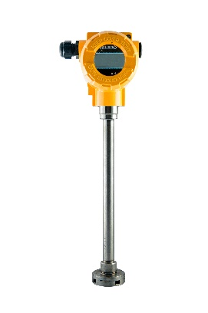  Connection : 1/2'' NPT , M20x1.5, G1/2'' ; Flush diphram (G1/2'' , G1'' , M30x2) diaphram seals  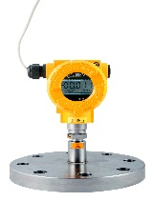 | Smart diffenetial pressure transmitter  APR - 2000 ALW  Measuring range : Up to 70 Bar  Output Signal : 4 - 20 mA + HART  Intrinsic safety and explosion proof certificates  Accuracy : 0,075 % ( Special version 0,05 % 0,04 % )  Housing material : Aluminum / 316 Stainless Steel  Hastelloy Or Tantalum diaphrams  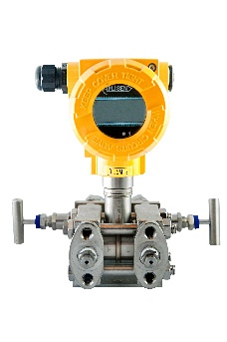  Connection : 1/2'' NPT , M20x1.5, G1/2'' ; Flush diphram (G1/2'' , G1'' , M30x2) diaphram seals  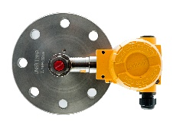
Hydrostatic level probes  SGE-25 ,  Measuring range : Fr0m 200 Up to 3000 mmH2O  (Up to 20m APC - 2000 ALW/L)  Output Signal : 4 - 20 mA + HART  Intrinsic safety and explosion proof certificates  Accuracy : 0.16 %  Version with Local display  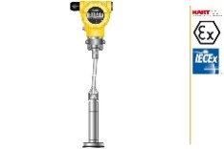  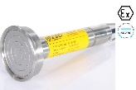  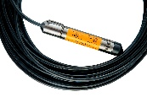 | Temperature transmitters  APT- 2000 ALW  Head-mounted, Rail-mounted and industrial temperature trasmitters  Output Signal : 4 - 20 mA + HART Protocol  Thermoresistance line compensation ( 3 Wire line )  ATEX certificate (Exia and Exd )  MID Certificate (only APT-2000 ALW )  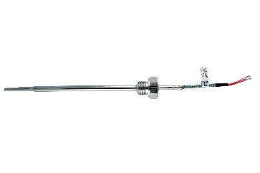  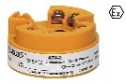  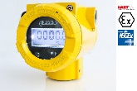  SIL2/SIL3 - Functional Safety Certificate (LI-24G,LI-24L)
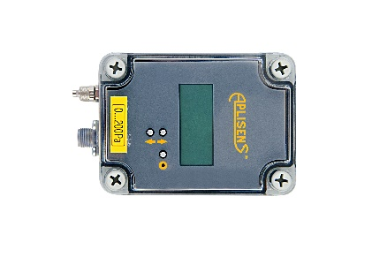  Displays & Accessories  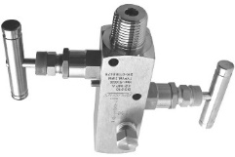  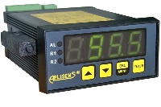  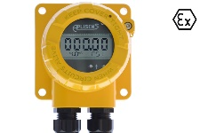  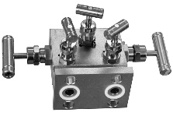  WWW-11ALW , WW-45 , VM-3 | Electropneumatic positioners  APIS HART protocol  ATEX certificate II 2G Exia IIC T6/T5 Gb  Simple in installation and programming  Possibility of remote assembling of positioner  Low air consumption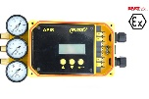  Programmable speed of movement of the actuator’s piston rod  Position transmitter  Possibility of manual controlling of position of actuator’s piston rod
Electromagntic Flowmeter
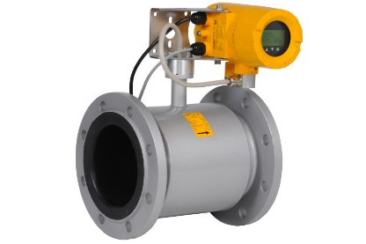
PME- 1000
Nominal size: DN10...1000 / ANSI 0,5...24“
Maximum static pressure 1,6MPa
Accuracy: 0,5% or 0,2%
Analog outputs: 4...20mA
Lining : Rubber or PTFE
Communication interface: Modbus RTU / RS 485
Pulse output (uni- or bidirectional) or frequency output

